VIETNAM GENERAL CONFEDERATION OF LABOR

**TON DUC THANG UNIVERSITY**

**FACULTY OF INFORMATION TECHNOLOGY**



**FINAL REPORT**

**WEB PROGRAMMING AND APPLICATIONS**

**WEBSITE SPORT NEWS**

*Instructor*: **NGUYEN NGOC PHIEN**

*Executor*: **VO NHAT HAO - 522H0090**

**DANG THANH NHAN – 522H0006  
NGUYEN THANH NHAN – 522H0051**

Class **: 22H50202 – 22H50201**

Course  **: 26**

**HO CHI MINH CITY , YEAR 2024**

VIETNAM GENERAL CONFEDERATION OF LABOR

**TON DUC THANG UNIVERSITY**

**FACULTY OF INFORMATION TECHNOLOGY**



**FINAL REPORT**

**WEB PROGRAMMING AND APPLICATIONS**

**WEBSITE SPORT NEWS**

*Instructor*: **NGUYEN NGOC PHIEN**

*Executor*: **VO NHAT HAO - 522H0090**

**DANG THANH NHAN – 522H0006  
NGUYEN THANH NHAN – 522H0051**

Class **: 22H50202 – 22H50201**

Course  **: 26**

**HO CHI MINH CITY, YEAR 2024**

THANK YOU

I would like to sincerely thank Lecturers Nguyen Ngoc Phien, our names are Vo Nhat Hao, Nguyen Thanh Nhan, Dang Thanh Nhan, with MSSV: 522H0090, 522H0051, 522H0006. We would like to send our most sincere thanks to the teacher for directly teaching and imparting to us knowledge from the foundation to advanced levels of the Web and Application Programming subject, allowing us to understand the content. content as well as the meaning and application of the subject. We would also like to thank the teacher for his dedicated guidance, support and creating conditions so that we can best complete this report. We hope to continue to receive teaching and support from you in the near future. We sincerely thank you.

**THE PROJECT IS COMPLETED**

**AT TON DUC THANG UNIVERSITY**

I hereby declare that this is my own project product and is guided by Lecturers Nguyen Ngoc Phien. The research content and results in this topic are honest and have not been published in any form before. The data in the tables for analysis, comments, and evaluation were collected by the author from different sources and clearly stated in the reference section.

In addition, the project also uses a number of comments, assessments as well as data from other authors and other organizations, all with citations and source notes.

**If any fraud is discovered, I will take full responsibility for the content of my project**. Ton Duc Thang University is not involved in copyright violations caused by me during the implementation process (if any).

*Ho Chi Minh City, 20 April , 2024*

*Author*

*(sign and write full name)*

*Vo Nhat Hao*

*Nguyen Thanh Nhan*

*Dang Thanh Nhan*

INSTRUCTOR VERIFICATION AND EVALUATION SECTION

**Confirmation from the instructor**

_______________________________________________________________________________________________________________________________________________________________________________________________________________________________________________________________________________________________________________________________________________________________________________________________________________

Ho Chi Minh City, day month year

(sign and write full name)

**The teacher's evaluation part marks the test**

_______________________________________________________________________________________________________________________________________________________________________________________________________________________________________________________________________________________________________________________________________________________________________________________________________________

Ho Chi Minh City, day month year

(sign and write full name)

SUMMARY

1. **Results achieved**

• Analyze and evaluate basic news website requirements.

• Apply HTML, PHP, MYSQL and Visual Studio Code tools to build news websites.

• User interface: friendly interface, allowing readers to easily view news, search for news, post articles, comments for each news along with the games that the website provides.

• Administration part: The website's data management system has been built, helping administrators easily manage information and data, view, add, delete, and update data for the website.

1. **Development direction**

Today, the internet has become a huge and convenient means of searching for information for everyone in the world. Studying and finding information online has also become extremely popular. Understanding the importance of news, I always want to improve my news website better, analyze the requirements more carefully and build a more complete and professional interface.

TABLE OF CONTENTS

THANK YOU 1

INSTRUCTOR VERIFICATION AND EVALUATION SECTION 3

SUMMARY 4

TABLE OF CONTENTS 5

CHAPTER 1 – WEBSITE DESCRIPTION 6

1. 1 Introduction to the website 6

1. 2 Website development tools 6

CHAPTER 2 – FUNCTION DESCRIPTION 7

2. 1 Login function 7

2. 2 Registration function 7

2. 3 Search function 7

2. 4 Functions of admin 7

CHAPTER 3 – DEMO 8

3. 1 Login function 8

3. 2 Registration function 8

3. 3 Home page 9

3. 4 Search function 10

10

3. 5 Comment function 10

3. 6 Functions of admin 11

3. 7 Manage news types 12

3. 8 Article management 13

14

3. 9 User management 14

CHAPTER 1 – WEBSITE DESCRIPTION

1. Introduction to the website

* Our website is called Sport News, it is intended to help everyone see information about sports, search for articles by input information, by name.
* Our website is built with 2 main parts: for users and admin.
* “The information accumulated in each of us is called knowledge, the most valuable asset of humans”
* With the explosion of information on the internet, the role of online information sites becomes even more important. Unlike traditional newspapers that have limited time to update news, online newspapers provide convenience in updating and releasing information. On the user side, they can view information anytime, anywhere. As for information providers and journalists, they can easily update the latest and most current news. Therefore, using online information sites is always necessary today to meet each person's need to update information.
* News is things that have happened, good or bad, to help people know about things around them and in the world. Today, thanks to fast communication, no matter what has happened anywhere in the world. then we can all know right away, thanks to that we can learn many good things.
* News is extremely important, it gives people knowledge and is the basis for people to do everything big and small. When there is the Internet, news is even more important because it spreads quickly and affects immediately on a large scale.

1. Website development tools

* In terms of interface: the website is built using languages such as HTML, CSS and Javascript. This includes using libraries to support the development process to use icons, fonts, etc. to make programming as well as user experience more convenient.
* Functionally: implemented in the PHP programming language.
* About data storage: data is stored in mySQL.

CHAPTER 2 – FUNCTION DESCRIPTION

1. Login function

* The user will enter account information and password into the login interface. If the login is successful, it will go directly to the index page containing the main interface of the website. If the login fails, the system will issue a notification that the login failed and reload the login page. If it is an admin account, it will be redirected to the management page.

1. Registration function

* Users can fill in the necessary personal information in the registration form. The system will then check if the account and information are valid, there will be a notification of successful registration, then the user will be redirected to the login section.

1. Search function

* Users will enter the player's name and the name of the article in the search box. The user will then be redirected to the search results page to see the results. The results are articles that satisfy the search criteria. If there are no matching articles, it will display that no results were found.

1. Functions of admin

* Admin can add, delete and edit information of articles, users, and news types.

CHAPTER 3 – DEMO

1. 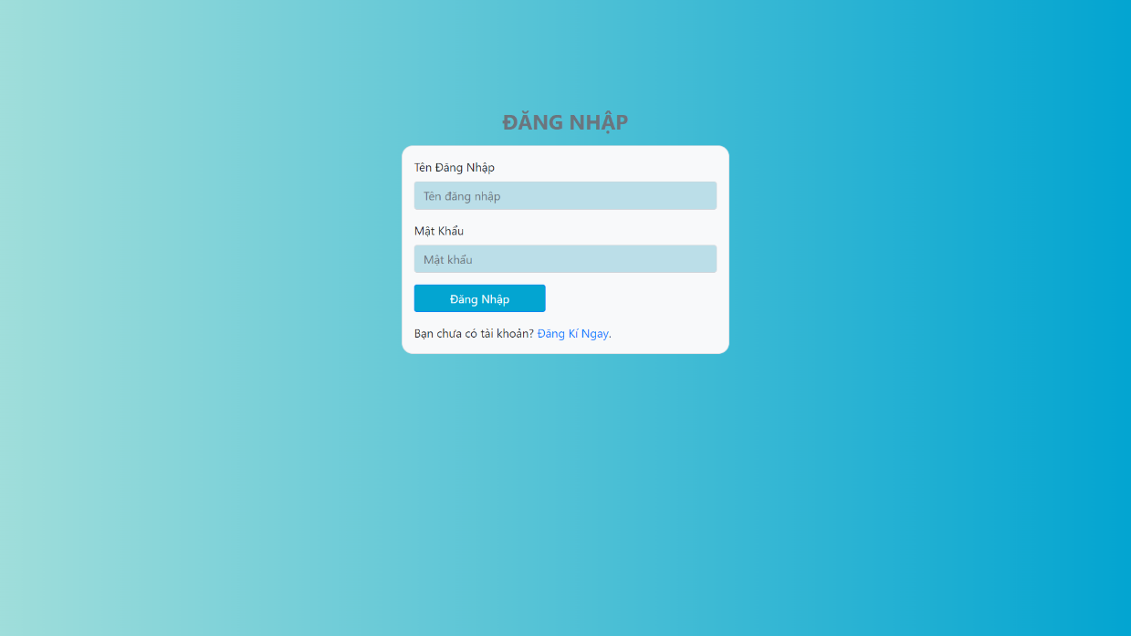Login function
2. Registration function

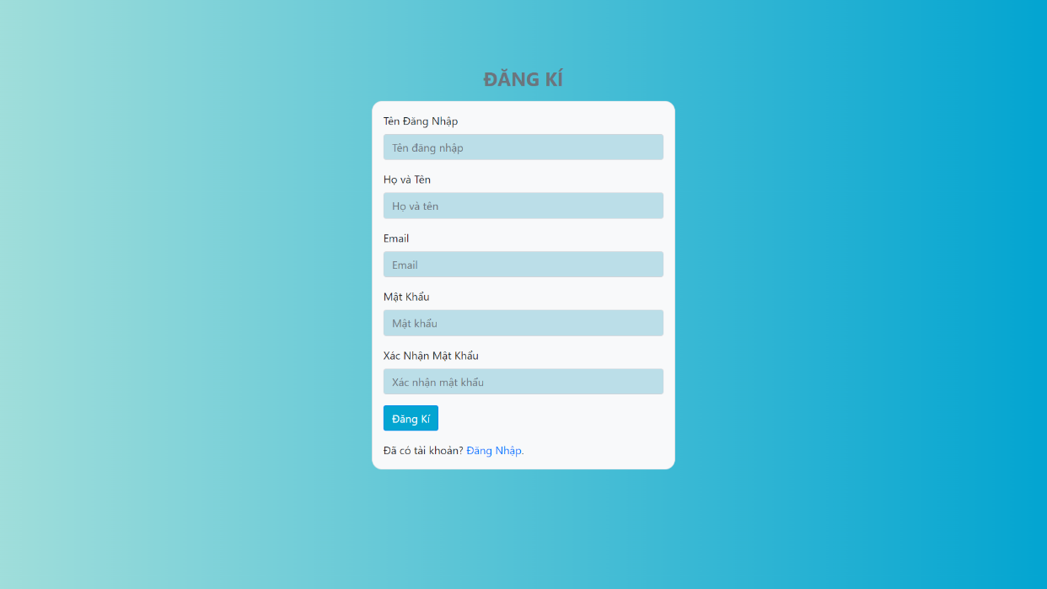

1. 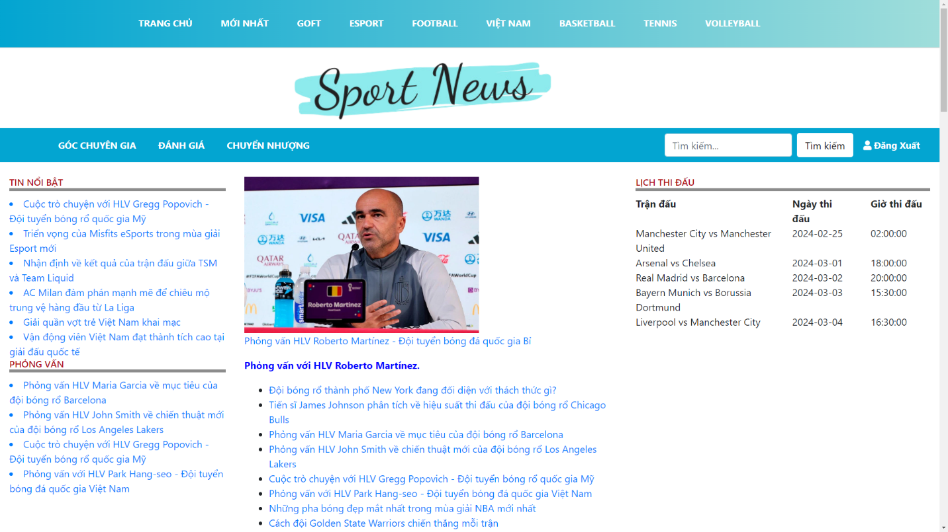Home page
2. Search function

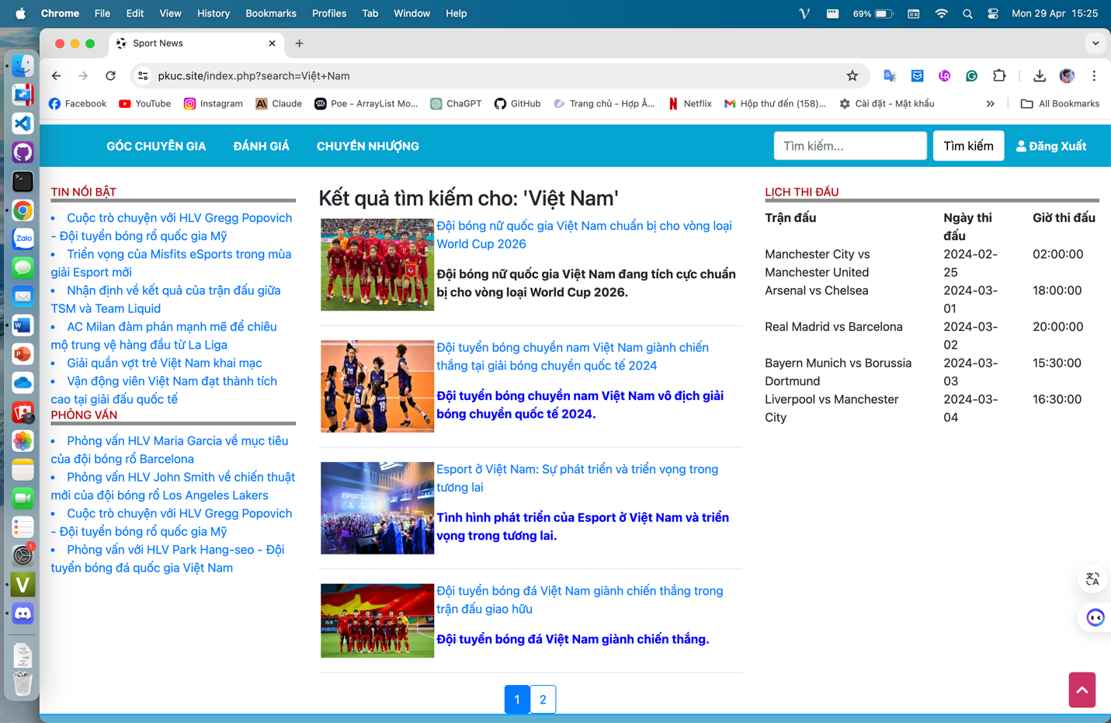

1. A screenshot of a video chat

   Description automatically generatedComment function
2. 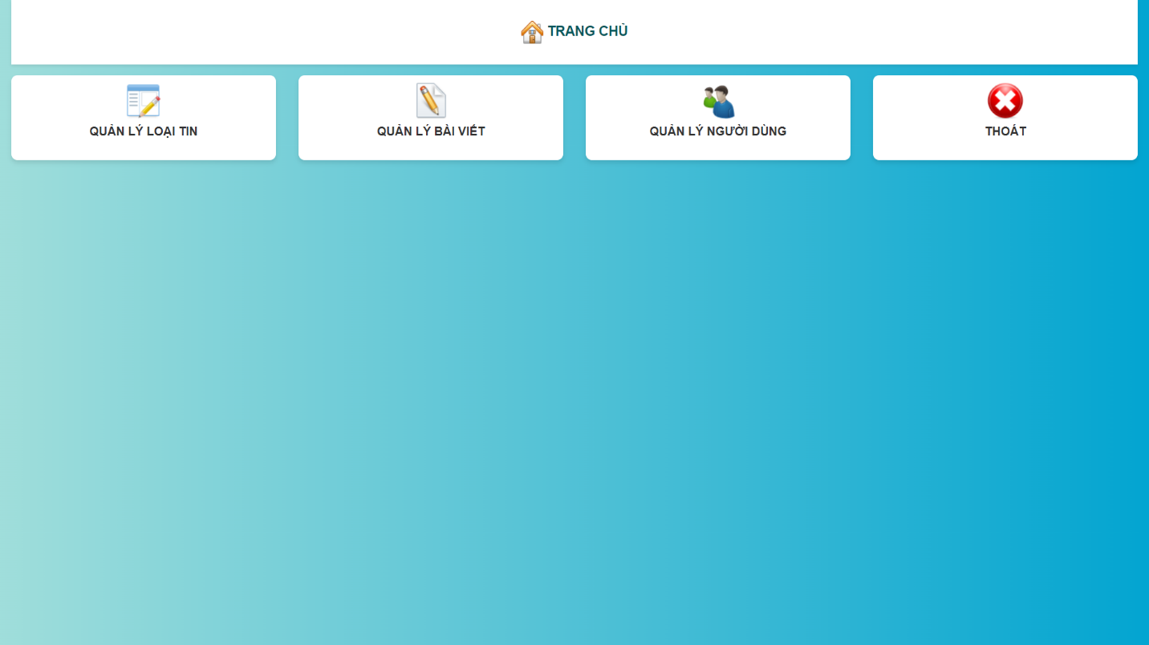Functions of admin
3. 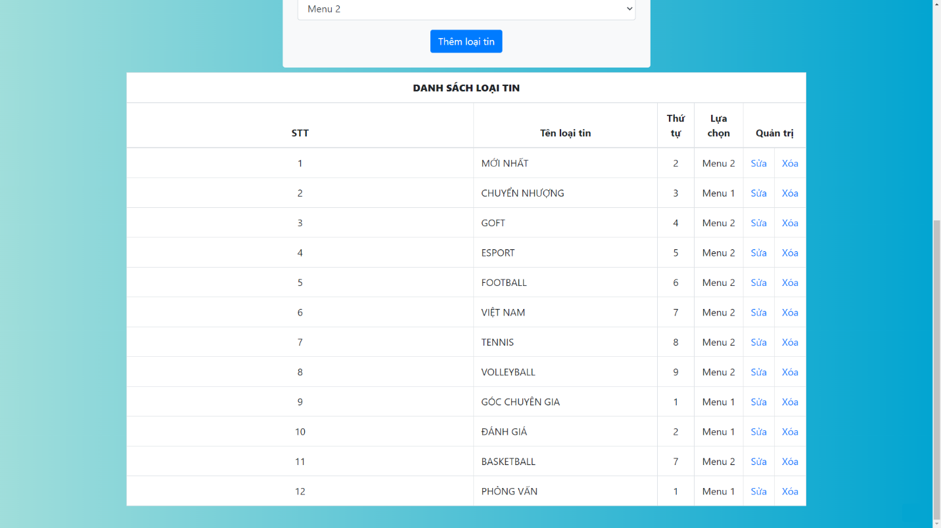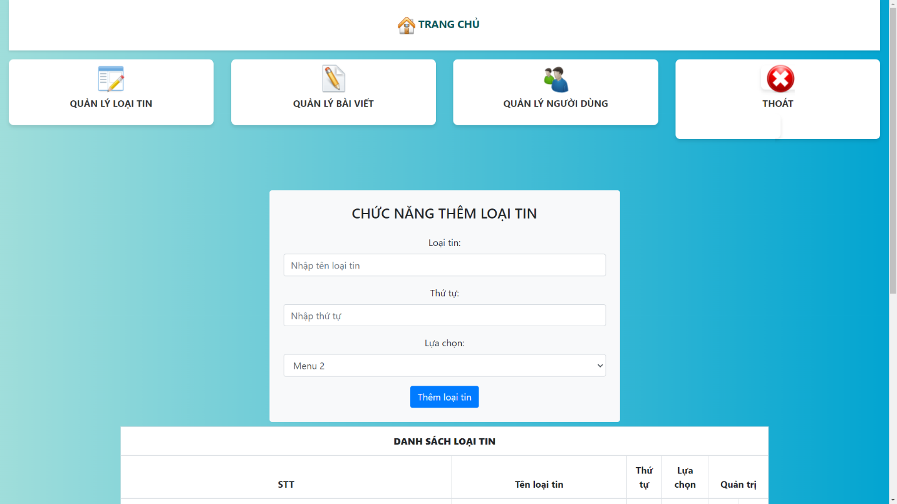Manage news types
4. 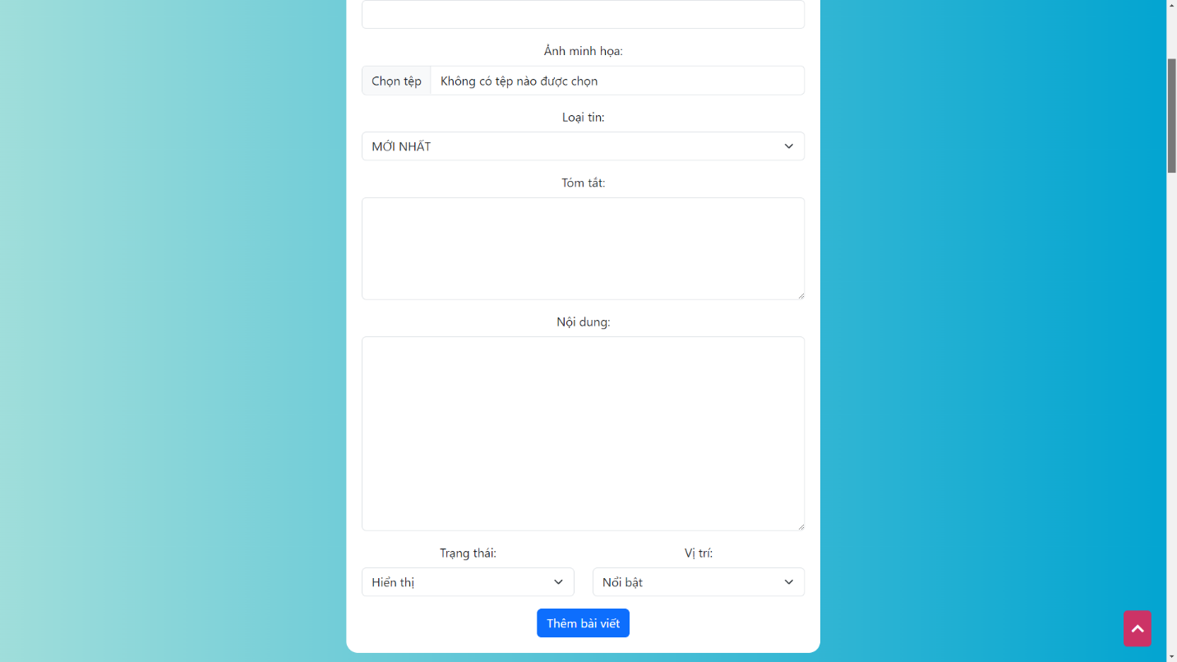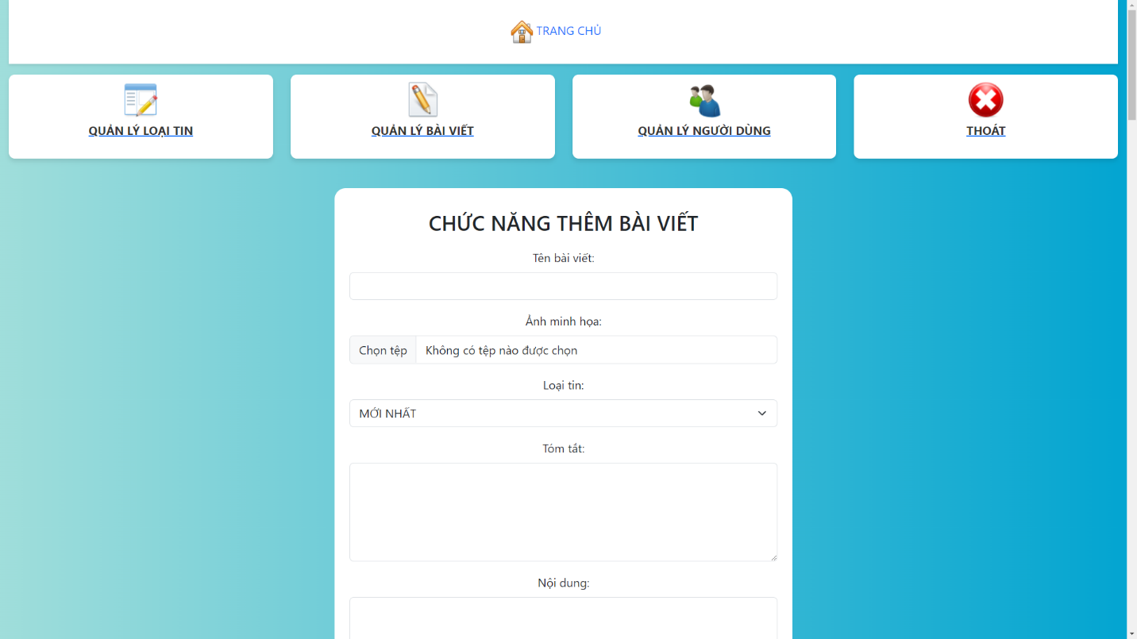Article management

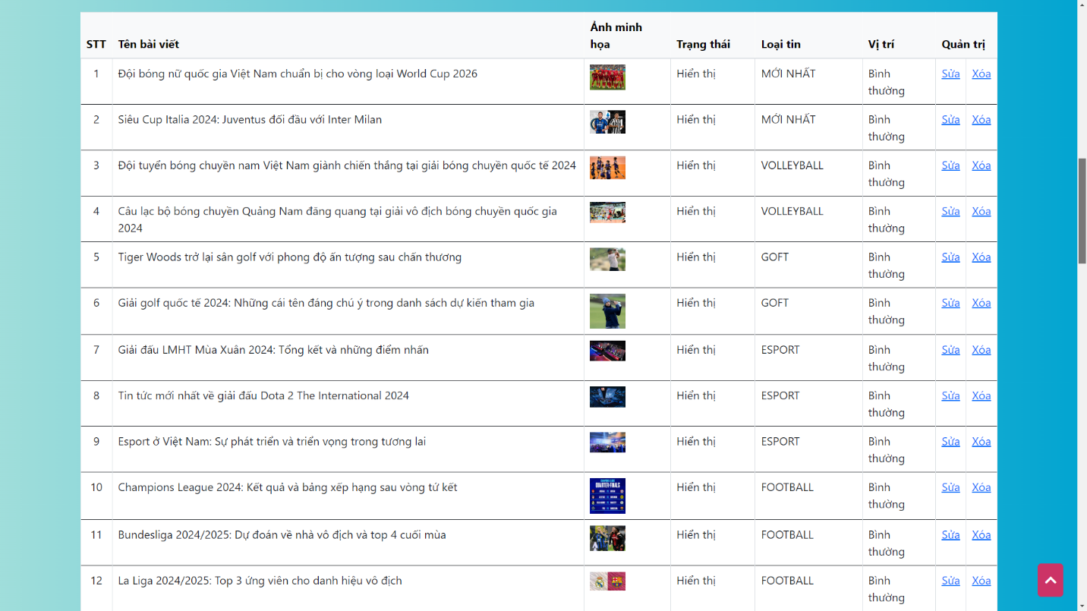

1. 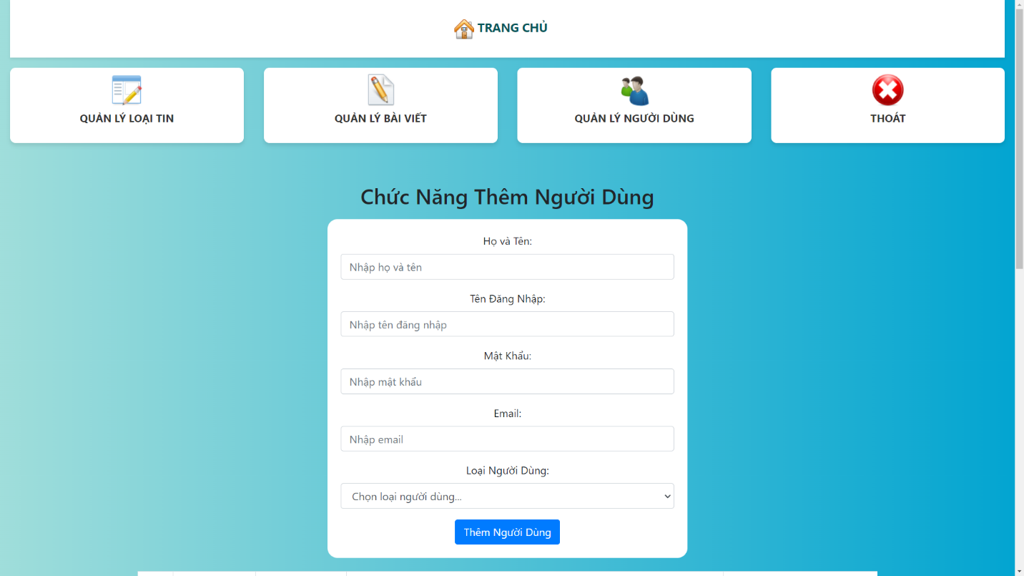User management

